Answer 5
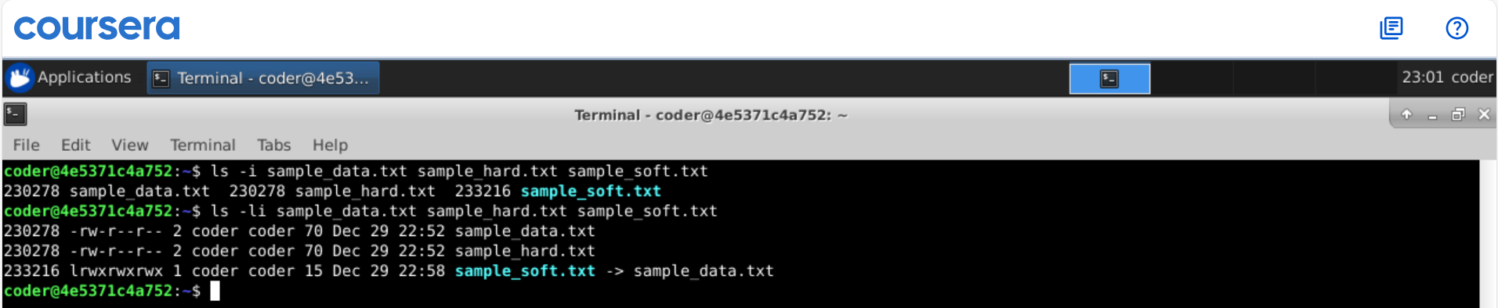
Explanation: As seen Hard link of the source file shared the same Inode number, because when we create a hard link, it doesn’t create a new file instead it just creates a copy of the same Inode number. Deleting the source file will not leave the hard link dangling, instead hard link will help to keep the file accessible as it has same inode number .

